**CMIS 242 6382 Intermediate Programming – Project 3**

Student Name: Xingyi Zhang

Instructor: Vladimir Gubanov

Date: June 29, 2020

**Test Cases and Result Displays**

1. **Default setting result:**

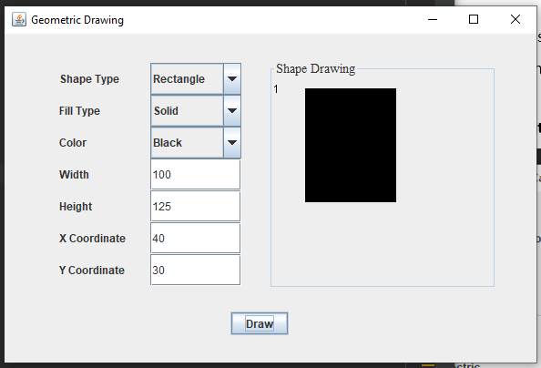

Analysis:

Position, color, shape, and number on the upper left corner match with the user input values.

This test case is passed.

1. **Change the shape, color, position, and make it hollow:**

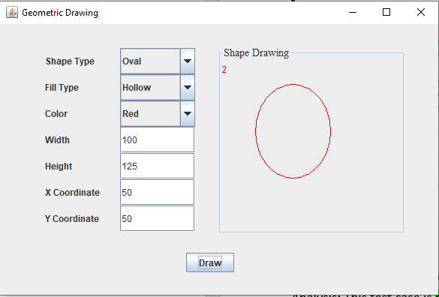

Analysis:

Position, color, shape, and number on the upper left corner match with the user input values.

The program has passed this test case.

1. **Change the vertical coordinate to make it outside of bounds:**

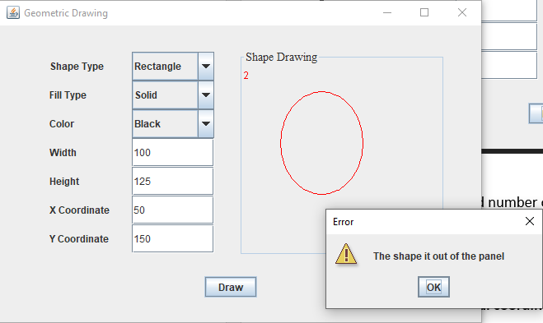

Analysis:

The y-coordinate with the height of the shape is beyond the edge of drawing panel. The correct error message was displayed.

The program has passed this test case.

1. **Change the position, shape, and color again:**

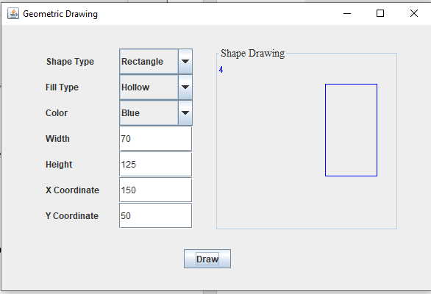

Analysis:

Position, color, shape, and number on the upper left corner match with the user input values.

Note that the number is 4 instead of 3, because I drew another shape without recording.

The program has passed this testcase.

1. **Enter an invalid input:**

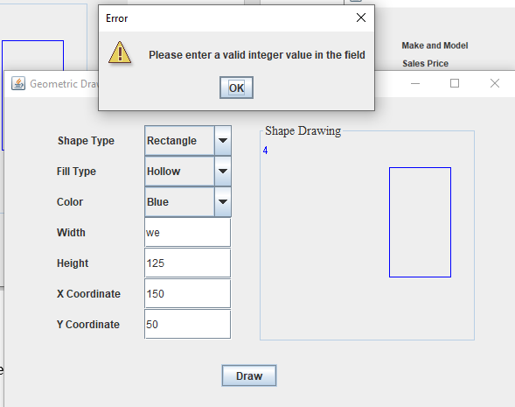

Analysis:

The width value entered was not a valid integer.

The program has passed this testcase.

**OVERALL ANALYSIS:**

The Program has successfully passed all test cases.